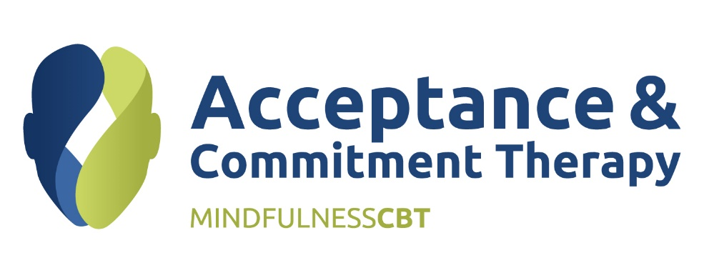

**ACT For Living With Chronic Pain Workshop**

***Overview***

This workshop is designed to help practitioners deepen their understanding and practice of working with Chronic Pain. Chronic pain can be a source of immense human suffering and disability. There is evidence indicating that as pain sufferers set aside struggles for control over pain, attend to present experiences, and engage in meaningful activities, they suffer less and function better, even while pain persists. These treatment processes are respectively referred to as acceptance, mindfulness, and values-based action and are core therapeutic processes of ACT Therapy. As complex chronic pain patients are often receiving treatment from multiple providers, the multi- and interdisciplinary aspects of treatment will be focused upon.

***Objectives***

Participants will gain knowledge and understanding of:

* the nature of complexity in chronic pain from an ACT perspective and an enhanced skill base when it comes to addressing this complexity.
* Applying practiced clinical exercises to initiate an effective direction in treatment
* Applying practiced clinical exercises designed to augment acceptance and mindfulness, as well as aid in values clarification and the promotion of values-based action for use in chronic pain settings.
* a holistic approach to treatment and package of care combining physiotherapy and ACT

***Presenters***

Katie Hall (Physiotherapist) & Elizabeth Maher (ACT Therapist and Trainer)

***Length***

2 days from 9am to 3.30pm.